Scalar Function, F(x,T,t),
with three independent variable, x,T, and t

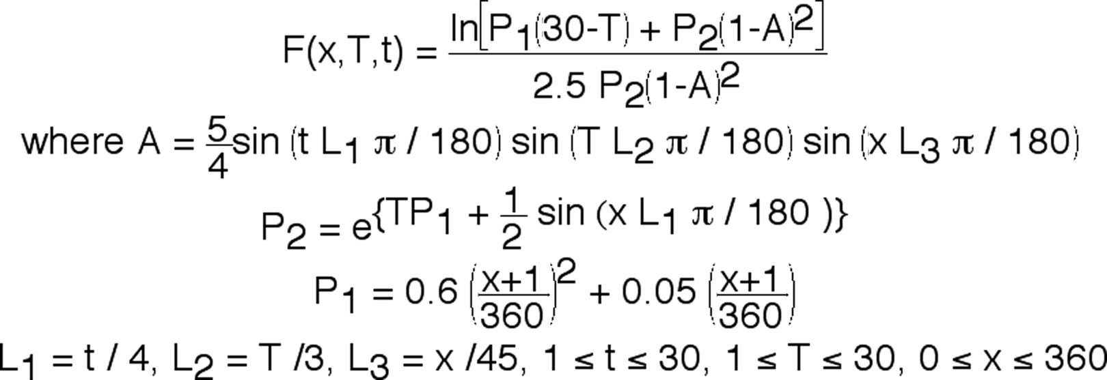

Plot most significant results of function F(x,T,t) on a page.

